Weekly Guide

**Pasco-Ray Programming Guide**

**Team RUSH 27 Labview**

**Matt Pasco**

**Michael Ray**

**Common Problem and Solutions**

**Table of Contents**

1. Table of Contents
2. Check List
3. E-Stop
4. Redeploying Code
5. Rebooting the Radio
6. Rebooting the Radio Continued
7. Reimaging the cRio

**Week 1**

* Identify Control Elements
  + Defined Motors and Sensors
  + 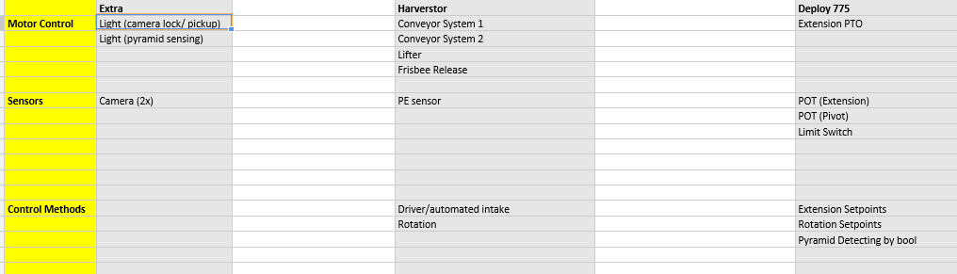
* Mapped out software block & Defined/Mapped Digital I/O
  + 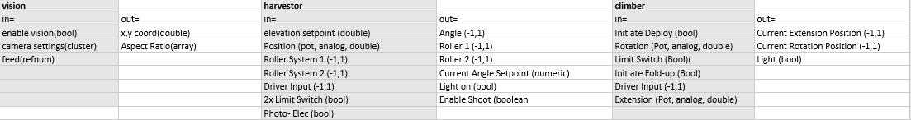
* Working On Functional Designs
  + 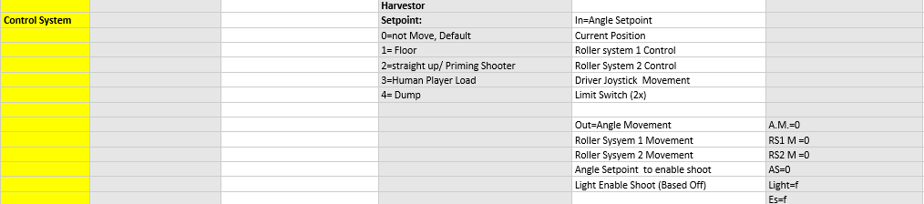
* Variables
  + Naming Syntax
    - Name it something to do with the action

**Week 2**

* Go over and negotiate sensors
* Make design assumptions to be checked with team
  + The rollers can move when the robot is moving
  + Check with team
  + If it has changed update code logic